## TALLER 01

1. *CREAR LOS SGTES TABLESPACES EN LA CARPETA C:\PRACTICA*

CREATE TABLESPACE TB_COMERCIAL

DATAFILE 'C:\PRACTICA\DF_COMERCIAL_01.DBF'

SIZE 15M;

CREATE TABLESPACE TB_FINANZAS

DATAFILE 'C:\PRACTICA\DF_FINANZAS_01.DBF'

SIZE 10M;

CREATE TABLESPACE TB_FINANZAS

DATAFILE 'C:\PRACTICA\DF_FINANZAS_02.DBF'

SIZE 10M;

CREATE TABLESPACE TB_CONTABILIDAD

DATAFILE 'C:\PRACTICA\DF_CONTABILIDAD.DBF'

SIZE 10M;

CREATE TABLESPACE TB_LOGISTICA

DATAFILE 'C:\PRACTICA\DF_LOGISTICA_02.DBF'

SIZE 10M;

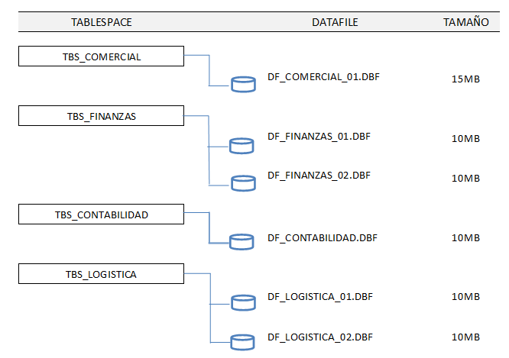*AGREGAR UN NUEVO DATAFILE A TBS_CONTABILIDAD DE 15MB.*

ALTER TABLESPACE TB_CONTABILIDAD

ADD DATAFILE 'C:\PRACTICA\DF_CONTABILIDAD_02.DBF'

SIZE 10M;

SELECT * FROM DBA_TABLESPACES;

1. *AMPLIAR EL TAMAÑO DEL UNICO DATAFILE ASOCIADO AL TBS_COMERCIAL A 25MB.*

ALTER DATABASE

DATAFILE 'C:\BDORACLE\DF_COMERCIAL_01.DBF'

RESIZE 25M;

1. *CREAR LA TABLA PEDIDOS EN TBS_LOGISTICA*

|  |  |  |
| --- | --- | --- |
| CAMPO | TIPO DATO | LONGITUD |
| IDPEDIDO | NUMBER | 10 |
| FECHA | DATE |  |
| REFERENCIA | CHAR | 100 |

CREATE TABLE PEDIDOS

( IDPEDIDO NUMBER(10),

FECHA DATE,

REFERENCIA CHAR(100) )

TABLESPACE TB_LOGISTICA;

1. *INSERTAR 10 MIL REGISTROS EN LA TABLA PEDIDOS, VERIFIQUE EL PORCENTAJE DE POBLAMIENTO.*

INSERT INTO PEDIDOS

SELECT LEVEL , SYSDATE, 'REF' || LEVEL

FROM DUAL CONNECT BY LEVEL <= 10000;

*CONSULTA DE TAMAÑO Y PORCENTAJE DE ESPACIO LIBRE*

*--------------------------------------------------------*

SELECT /* + RULE */ df.tablespace_name "Tablespace",

df.bytes / (1024 * 1024) "Size (MB)",

SUM(fs.bytes) / (1024 * 1024) "Free (MB)",

Nvl(Round(SUM(fs.bytes) * 100 / df.bytes),1) "% Free",

Round((df.bytes - SUM(fs.bytes)) * 100 / df.bytes) "% Used"

FROM dba_free_space fs,

(SELECT tablespace_name,SUM(bytes) bytes

FROM dba_data_files

GROUP BY tablespace_name) df

WHERE fs.tablespace_name (+) = df.tablespace_name

GROUP BY df.tablespace_name,df.bytes

UNION ALL

SELECT /* + RULE */ df.tablespace_name tspace,

fs.bytes / (1024 * 1024),

SUM(df.bytes_free) / (1024 * 1024),

Nvl(Round((SUM(fs.bytes) - df.bytes_used) * 100 / fs.bytes), 1),

Round((SUM(fs.bytes) - df.bytes_free) * 100 / fs.bytes)

FROM dba_temp_files fs,

(SELECT tablespace_name,bytes_free,bytes_used

FROM v$temp_space_header

GROUP BY tablespace_name,bytes_free,bytes_used) df

WHERE fs.tablespace_name (+) = df.tablespace_name

GROUP BY df.tablespace_name,fs.bytes,df.bytes_free,df.bytes_used

ORDER BY 4 DESC;

1. *ELIMINAR EL TABLESPACE TBS_CONTABILIDAD. VERIFICAR.*

DROP TABLESPACE TB_CONTABILIDAD

INCLUDING CONTENTS AND DATAFILES;

SELECT * FROM DBA_TABLESPACES;

1. *CAMBIAR EL ESTADO DEL TBS_LOGISITCA A OFFLINE, CONSULTE LA TABLA PEDIDOS, QUE SUCEDE. PORQUE?*

ALTER TABLESPACE TB_LOGISTICA OFFLINE;

SELECT * FROM PEDIDOS

Porque se ha desactivado

1. *MODIFICAR EL ESTADO DE TBS_LOGISTICA A ONLINE, CONSULTE LA TABLA PEDIDOS.*

ALTER TABLESPACE TB_LOGISTICA ONLINE;

SELECT * FROM PEDIDOS